***Web Hackathon***

Bina Nusantara Computer Club

|  |  |  |  |
| --- | --- | --- | --- |
| **Version** | **Description of Change** | **Author** | **Date** |
|  |  |  |  |
|  |  |  |  |

1. **Purpose**

*[Berisi gambaran keseluruhan dari tujuan pembuatan secara deskriptif dan detail agar menjadi bahan identifikasi tetang sistem yang akan diimplementasikan]*

1. **Scope**

*[Penjelasan yang menjadi acuan pengembangan pada project mengenai ruang lingkup sistem]*

1. **Required technology**

*[Daftar teknologi yang diperlukan dalam pengembangan project]*

|  |  |
| --- | --- |
| **Name** | **Purpose** |
| Laravel 5.7 | Framework PHP |
| Visual Studio Code | Text Editor |
| Atom | Text Editor |
|  |  |

1. **Flowchart**

*[Bagan dengan simbol-simbol tertentu yang menggambarkan urutan proses secara mendetail dan hubungan antara suatu proses (instruksi) dengan proses lainnya dalam suatu program*.*]*

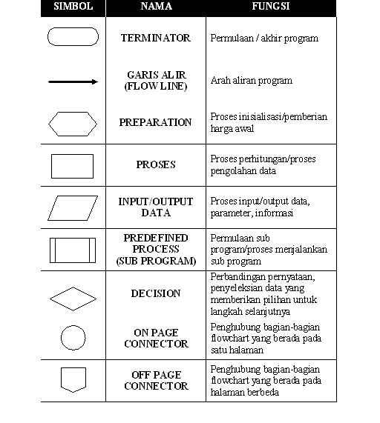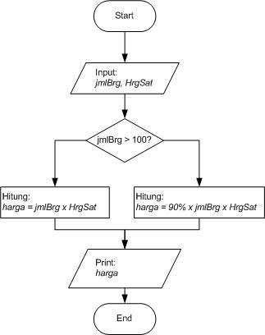

1. **Mockup UI**
   1. A screenshot of a cell phone

      Description generated with very high confidence**Login Form**

|  |  |  |  |
| --- | --- | --- | --- |
| **Module** | **Function** | **Condition** | **Feedback** |
| *Login Form* | *[Username input fields]* | *[Must be contain of ”@” ]* | *[Error message “Invalid username or password!”]* |
|  | *[Password input fields]* | *[Must be ]* | *[Error message “Username and password must be filled!”]* |

**Validation**

* 1. **Registration Form**

**A screenshot of a cell phone

Description generated with very high confidence**

|  |  |  |  |
| --- | --- | --- | --- |
| **Module** | **Function** | **Condition** | **Feedback** |
| *Registration Form* | *[Username input fields]* | *[Must be contain of ”@” ]* | *[Error message “Invalid username or password!”]* |
|  | *[Password input fields]* | *[Must be ]* | *[Error message “Username and password must be filled!”]* |
|  | *Asal sekolah* |  |  |
|  | *Email* |  |  |
|  | *Nama* |  |  |
|  | *Upload KTP* |  |  |

**Validation**

* 1. **A screenshot of a social media post

     Description generated with very high confidenceAdmin**

**Validation**

|  |  |  |  |
| --- | --- | --- | --- |
| **Module** | **Function** | **Condition** | **Feedback** |
| *Admin* | *Verificate* | *Must be contain receipt* | *[Error message “Invalid username or password!”]* |